**Lesson 7 Demo 4**

**Docker Compose Setup**



Steps to be followed:

1. Setting up docker-compose
2. Creating a docker-compose file

**Step 1: Setting up docker-compose**

1.1 Install docker-compose using the command given below:

***mkdir compose-test***

***cd compose-test***

***pip --version***





1.2 Then type the command given below, to install docker-compose

***sudo pip install docker-compose***

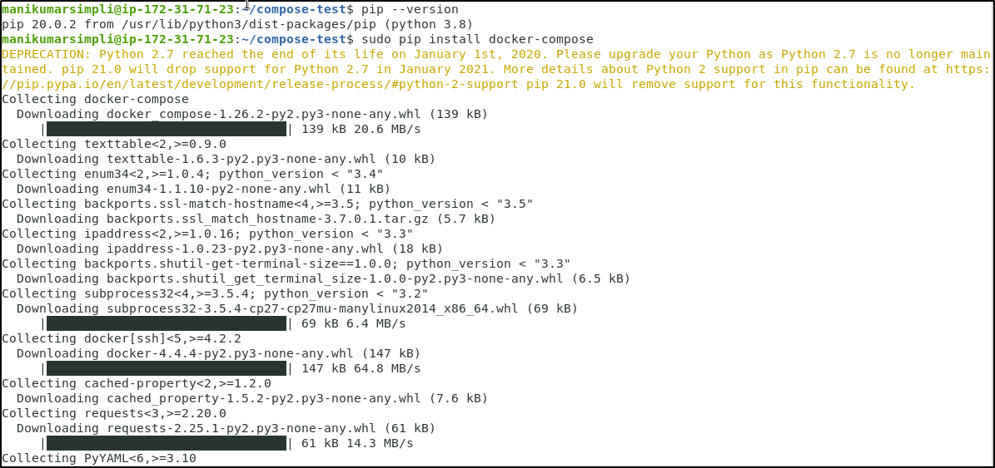

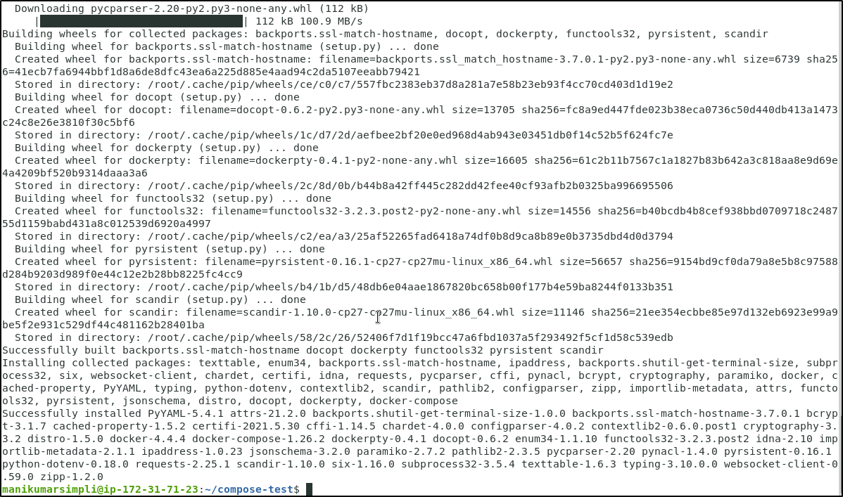

**Step 2: Creating docker-compose file**

2.1 Inside **compose-test** folder, create **docker-compose.yml** file, and add the following code in it:

***vi docker-compose.yml***

2.2 Add the following code snippet in the file:

***version: '2'***

***services:***

***compose-test:***

***image: centos***

***links:***

***- compose-db***

***command: /usr/bin/curl compose-db:6379***

***compose-db:***

***image: redis***

***expose:***

***- "6379"***

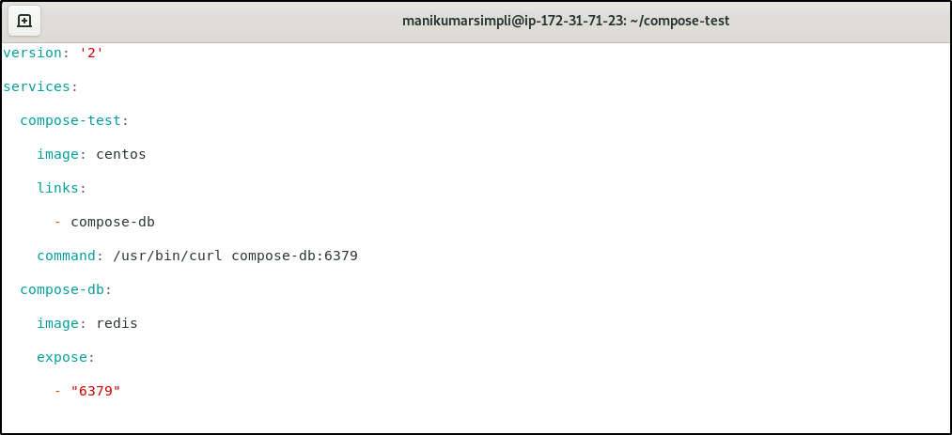

2.3 Run the following command to execute the yaml file:

**sudo docker-compose up**

